2023 Canadian Disciples’ Conference
(CDC) Report
By Philip Wong

Thank God for blessing the 2023 Canadian Disciples’ Conference “God’s Hope for You”. The theme of God’s hope was inspired by the challenges young people face today especially in the times that we are living in when there are so many false, lost or dead hopes in the world. God has great hope for young people in this generation. Young people today can change the world for Jesus.

God blessed this conference as we were praying for 100 people to attend. Over 115 people registered. Over the course of three days, from December 28-30, disciples of Jesus from 19 chapters from across Canada gathered online for this conference. We were encouraged and God worked to plant hope in the hearts of young people through the messages, testimonies, Bible studies, praise, prayer, and fellowship in Jesus.

For this conference, God raised up three messengers: Sion Lee from Humber/UTM UBF, gave our first message on Mark 3:13-19 when Jesus called the Twelve. Jesus called the Twelve disciples who were who were not among the elite of society, but Jesus chose ordinary men with hope for them, becoming disciples and eventually changed world history. Jesus called them because he wanted them to be with him and then to send them out. Jesus has hope for each of us as he personally calls us out of our hopeless situation to be with him and follow him. The second message was given by Samuel Mukwedeya from St. George UBF, who gave a message on John 4:27-42 “Open Your Eyes and Look at the Fields!” Through one person Jesus has hope for a great harvest among even a whole town or city. The Samaritan woman brought the whole town to come to know Jesus. Through one person, Jesus has hope to use us for a great harvest among the fields which are ripe. Jesus opens our eyes to the fields among our family and friends, our campuses, and our whole nation and even the world. The third message was given by John Koo from Vancouver 4, who spoke on 1Peter 1:3-9 “Living Hope in Jesus Christ.” All other hopes are dead hopes, but Jesus gives us a living hop because Jesus is alive. Through his resurrection, we have an inheritance that can never perish, spoiled, or fade – kept in heaven for us. Praise Jesus are living hope as we live today.

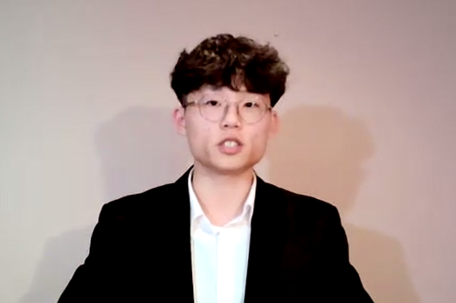 | 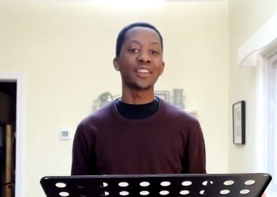 | 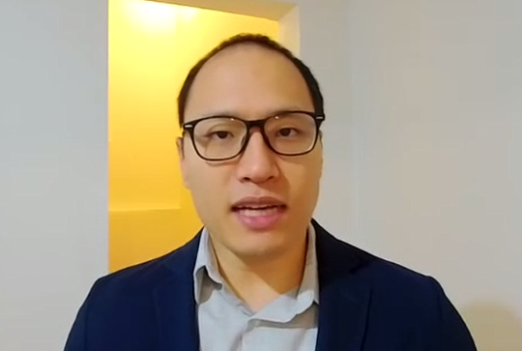
Sion Lee | Sam Mukwedeya | Paul Koo

God graced our conference, with six testimony speakers: Evangeline and Elizabeth (Montreal), Paul (Vancouver 3), Maria and Anne (Hamilton), and Alina (St. George). Each testimony revealed God’s, great grace in each person’s life who suffered from a deep sense of hopelessness in the world and found hope in the Lord Jesus.

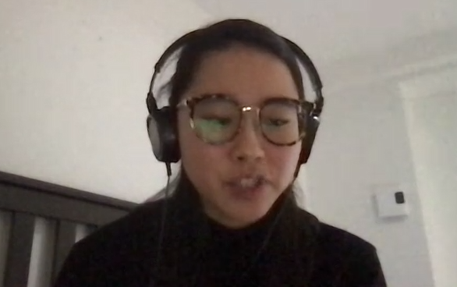 |  | 
Evangeline Chan | Maria Seo | Anne Seo
 |  | 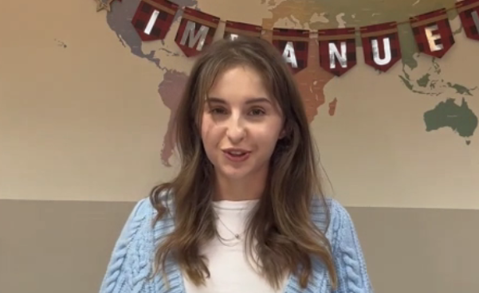
Paul Kim | Elizabeth Jumeau | Aline Chobanu

The conference also included two group Bible studies with 14 groups, led by young disciples. A workshop was given by Melissa Christopher (Montreal) on the topic of biblical sexuality based on Thessalonians 4:3a “For this is the will of God, your sanctification.” The workshop helped us to have a right understanding of sex and relationships and our identity as his holy creation. This was meaningful for young people who live in a time when there is so much immorality and confusion among sexuality may God bless young people to live as holy children of God, who can use their single life to fully serve Jesus, and also establish house, churches as examples for young families today. The ultimate goal when it comes to sexuality is to glorify God by denying ourselves, taking up our cross, and following Jesus.

Thank God for all his servants, who prayed and served this disciples conference: praise teams and music from St. George, Vancouver and Montreal; presiders Anna-Kaye (TMU), Alexandre (Ottawa), and Liza (Vancouver 3), the registration servant Joanna (Victoria) our IT servant Ian (Toronto), and other hidden servants. Special thanks to the planning team comprised of six people: senior servants of God (Philip Wong, Esther Kim, Joseph Song, David Chang) and junior servants of God (Joshua and Sion), who worked together beautifully to pray, prepare and serve this conference. All glory to God!!

