Messenger Training Workshop, Uganda UBF
Sh. Steven, Uganda

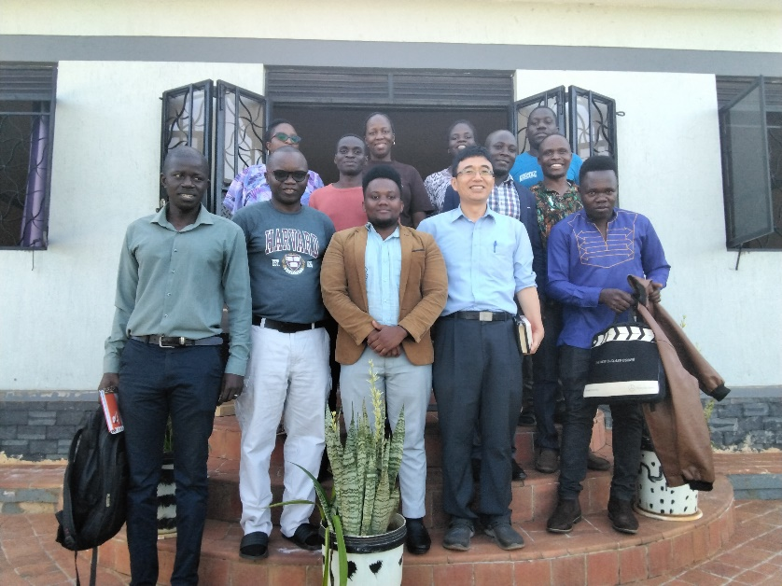
Uganda UBF held a two-day messenger training workshop on the 4th and 11th of March 2023 under the theme “Qualified”. The workshop was joined by messengers from both Makere and Kyambogo Chapters. The Key Verse was drawn from 1 Corinthians 9:27: “No, I strike a blow to my body and make it my slave so that after I have preached to others, I myself will not be disqualified for the prize” Through this workshop, we wanted to support messengers to deliver impactful student-centred messages and also refresh our spirit to deliver life-changing messages for world campus mission. The workshop begun with Sh. Steven sharing on why we need to undertake regular messenger training. We could learn that messengers are chosen by God and accountable to God. This was followed by Sh. John who shared on preaching to campus students and delivering focused messages. We could learn that knowing the student’s real experiences is important to deliver impactful messages to them. Dr. Luke Lim shared on the history of message delivery in UBF. We could learn our spiritual heritage for message preparation, the expository approach to message delivery and the example of Dr. Samuel Lee’s attitude to message preparation. After that Sh. Klaire shared about environment making for effective messages. Through her sharing, we could learn that messengers have to prepare physically, emotionally and prayerfully to deliver impactful message.

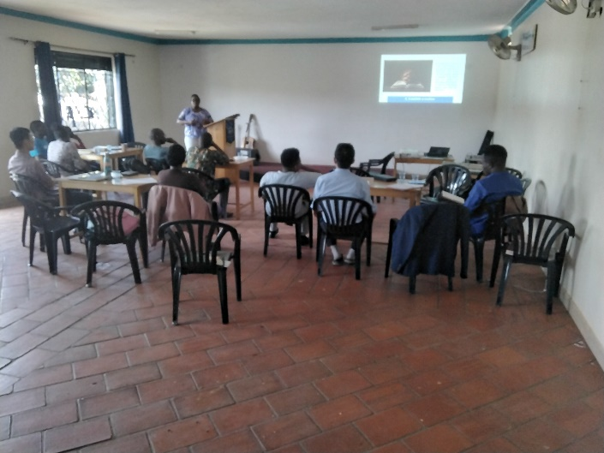
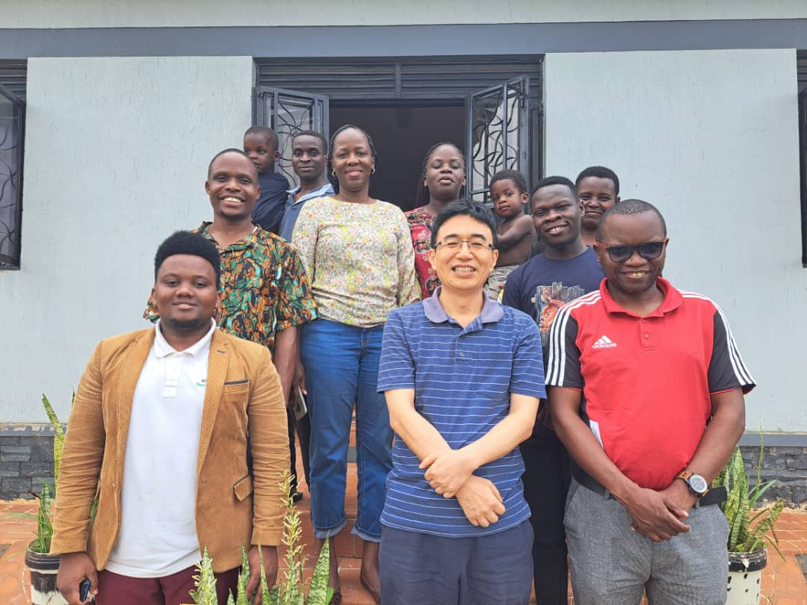
Sh. Albert shared on the basics of message preparation. We could be encouraged to be intentional in message preparation and to fix our eyes on Jesus as the origin of every message. On the next day, Dr. Livingstone Kang shared on what is good message, selecting a key verse and getting the main point. We were moved by the examples he gave using illustration of Jesus’ healing ministry. We could remember to always struggle with the text until we get God’s clear point to His people. Finally, Sh. Isaac drew his sharing from Heb 4:12 “For the word of God is living and active. Sharper than any double-edged sword, it penetrates even to dividing soul and spirit, joints and marrow; it judges the thoughts and attitudes of the heart”. We were encouraged that impactful messages have to be full of Jesus’ compassion and love. God’s message has inherent power. We have to deliver it as it is! After the interactive session, each of the participants went and prepared a short message from 1 Pet 3:11-17 and shared five-minute message. Through this practical session, we could apply the lessons we learnt, support one another to make our message better and encourage young messengers to grow in confidence to deliver God’s word. We thank God for this workshop. We could remember our duty as messengers and we could candidly share our struggles to prepare message. May God raise many messengers who can prepare powerful and impactful messages for Bible Uganda and World Mission.

End.

