UBF PANAMA
Winter Bible Conference & Mother’s Day in Panama
1 Peter 2:9: “But you are a chosen people, a royal priesthood, a holy nation, God’s special possession, that you may declare the praises of him who called you out of darkness into his wonderful light.”
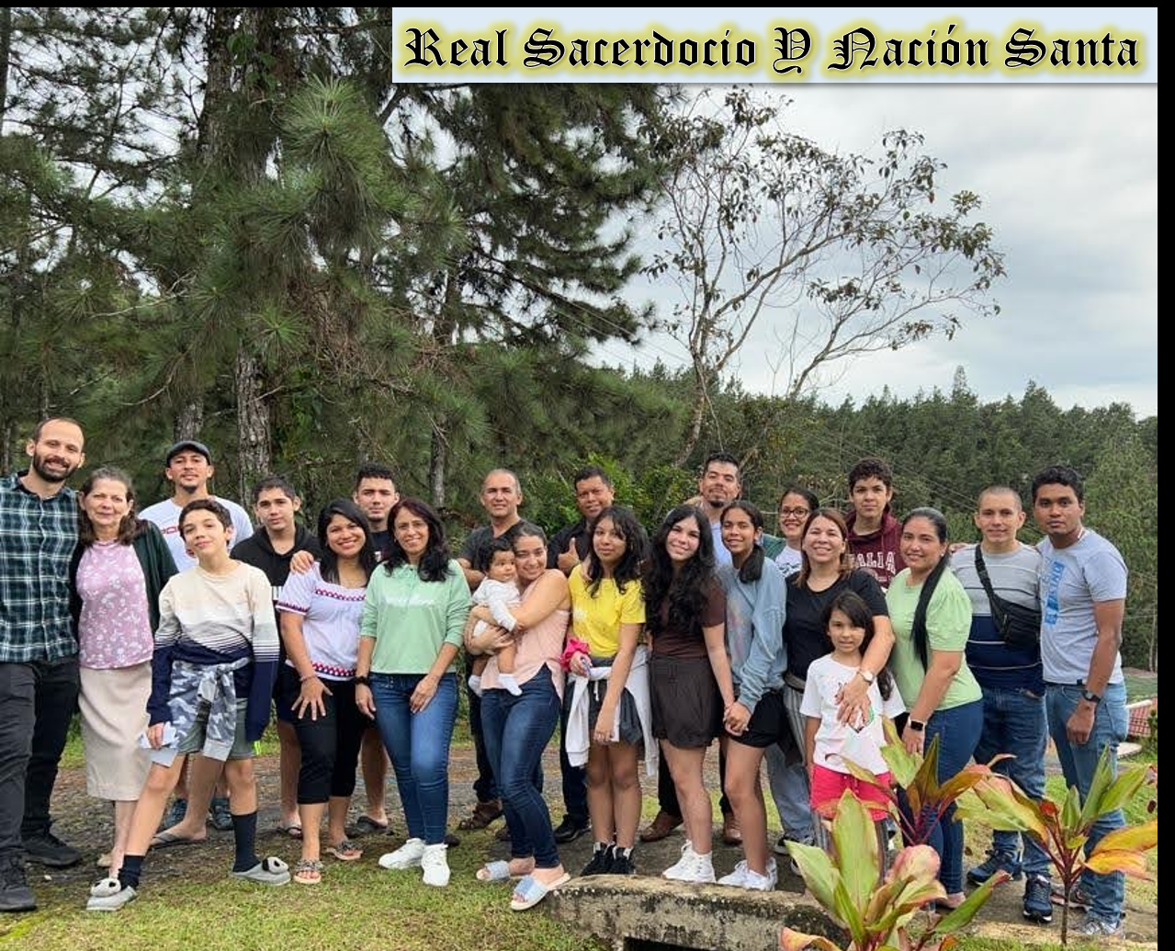

After 2 years of Pandemic, Panama UBF held one in-person Bible Conference again in the beautiful mountains just outside the city called “Cerro Azul” (Blue Hill) during Nov. 26~28 entitled: “Royal Priesthood And Holy Nation”. We rented two houses praying for 20 attendants, but one week before the conference we only had 12 confirmed. M. Josué (Joshua) challenged all members to invite to anyone, even though they couldn’t pay the registration fee, and two days before the conference we had 24 attendants confirmed! 16 adults, 5 teenagers and 3 children. Even 2nd gen Victoria (12yo) invited one classmate and one friend.
The conference start was delayed because we had many issues. Most of us got lost on the way to the place and once we arrived the door could not be opened. We had to break in through a window in order to get in! Then we had to set the conference place, distribute the rooms and prepare the dinner.
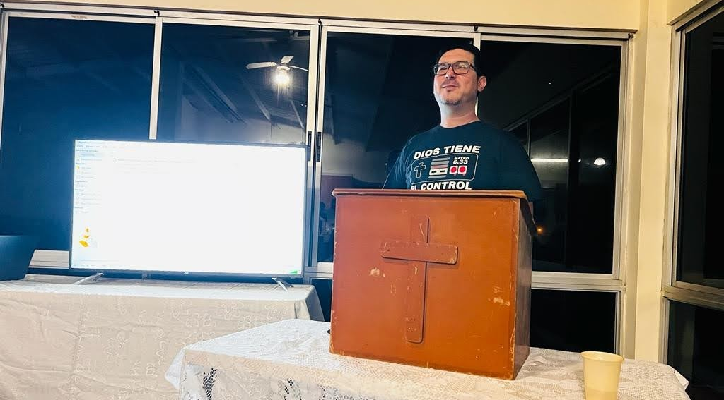
But once most of the attendants arrived, were accommodated and had dinner, we started with the welcoming words of M. Josué (Joshua) Gutierrez (below) and the worship.

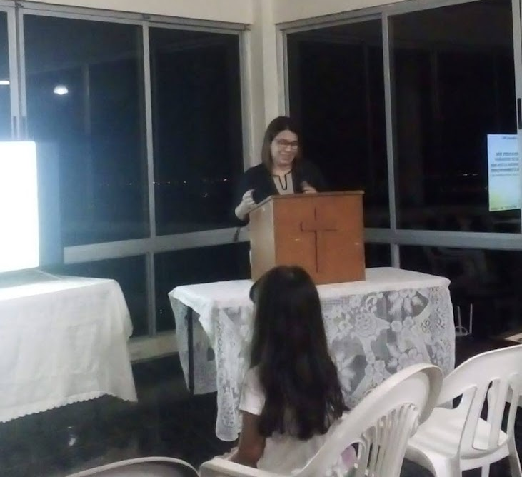
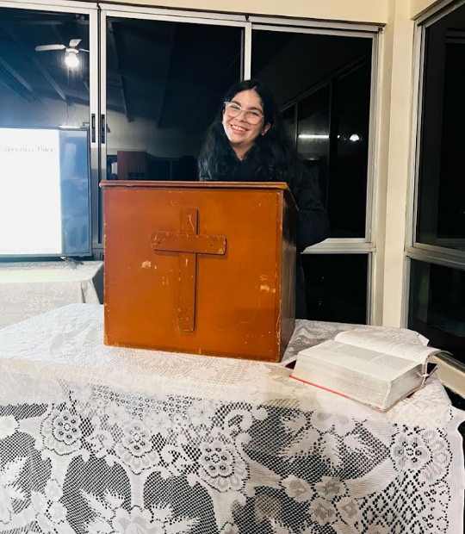
Afterwards, 2nd Gen Victoria read the Bible passage and M. Maria delivered the opening message: “Given Us New Birth into a Living Hope” based on 1Pe. 1:1-12. We were encouraged to have a living hope in Jesus for our salvation and to not put our hope in the earthly things which no last. We closed by praying together.

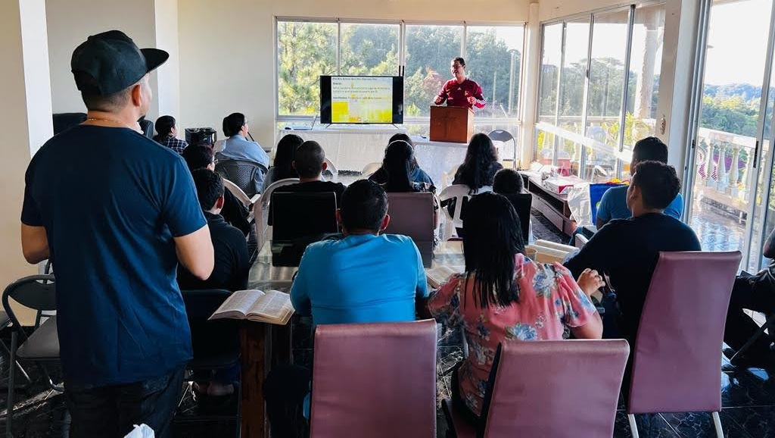
The second day of the conference started with the Daily Bread. We gathered together sing one song, and read Isa. 54:1-17 and the brief explanation on the Daily Bread Book, then M. Josué reflected on the passage and invited all attendants to enlarge the place of their tent and be prepared for what the Lord wants to give to us. We prayed together and had breakfast.
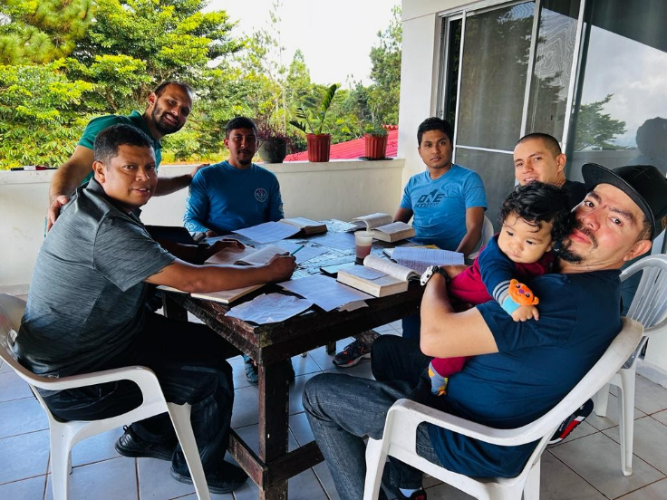
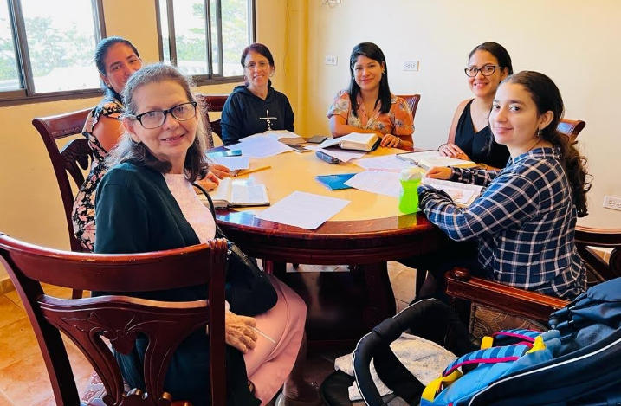
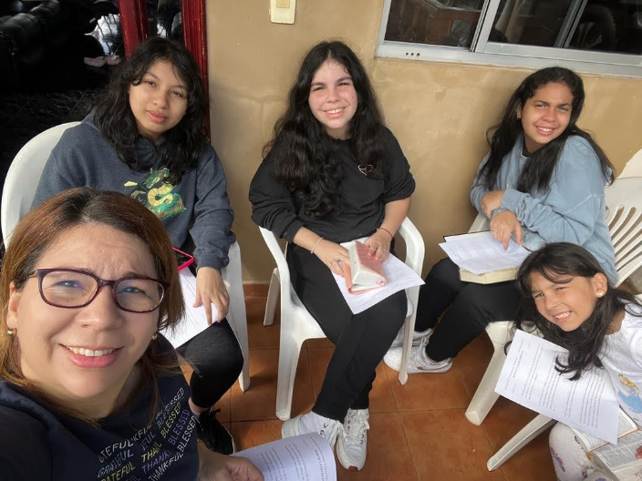
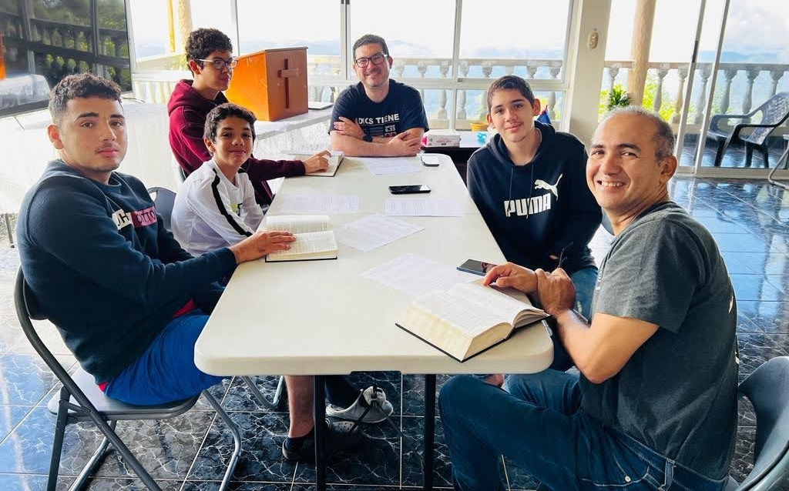
After the breakfast we had our first Group Bible Study. We were divided into 4 groups each one leaded by M. Josué, M. María, D. Darío and D. Karen. We studied 1Pe. 2:1-8: “Crave Pure Spiritual Milk”. We learned we need to crave the Word of God as the newborn babies crave their mother’s milk. If we do so, we will grow in our salvation.
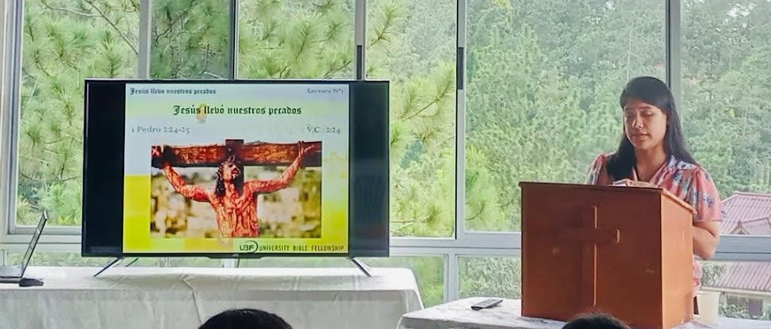
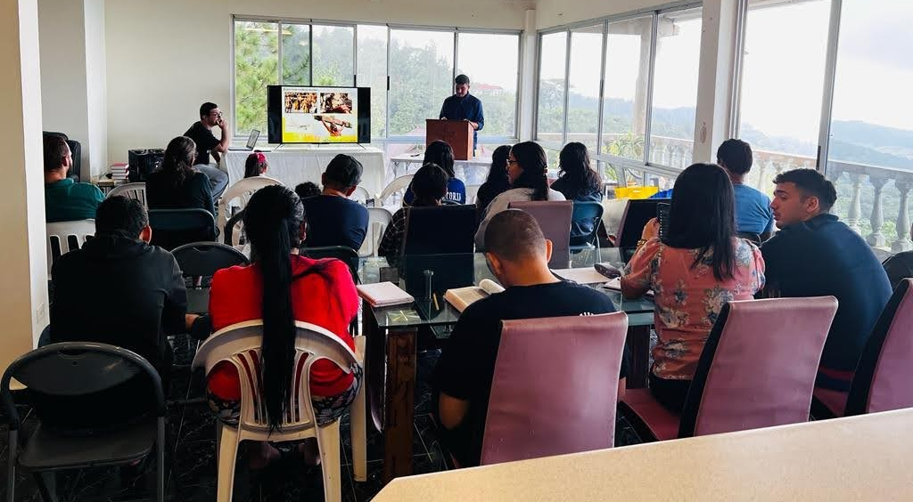
Later, D. Dario delivered the Lecture 1: “Jesus Bore Our Sins” based on 1Pe. 2:24-25. We learned what Jesus suffered before and during his crucifixion and the reason because he did it: He suffered and died for us, to bore our sins, forgive us and give us a new life. He bore our sins in his body on the cross, so that we might die to sins and live for righteousness. After the message, D. Karen (his wife) shared her heart-moving testimony showing that she was a lost sheep but she have returned to Jesus, her Good Shepherd.

After the lunch, we wrote and shared reflections. Many attendants were moved by the Word of God and desire to change their lives and continue to study the Bible. Most of the people continued to share the grace of God each other until the dinner time. After the dinner, we watched the movie: “Do You Believe?” Where the power of the cross change the lives of 12 people. All of us were greatly moved by the movie and wanted to live as true believers.
The third day of the conference started with the Daily Bread again. We followed the same steps than the day before by reading and reflecting Isa. 55:1-13. M. Josué invited to all who were thirsty to come to Jesus and drink the living water. Then, we prayed two by two and had breakfast. After that, we had our second Group Bible Study in 1Pe. 1:13-25: “Be Holly in All You Do”. Where we were called to be holy in all aspects of our life by obeying the Bible.
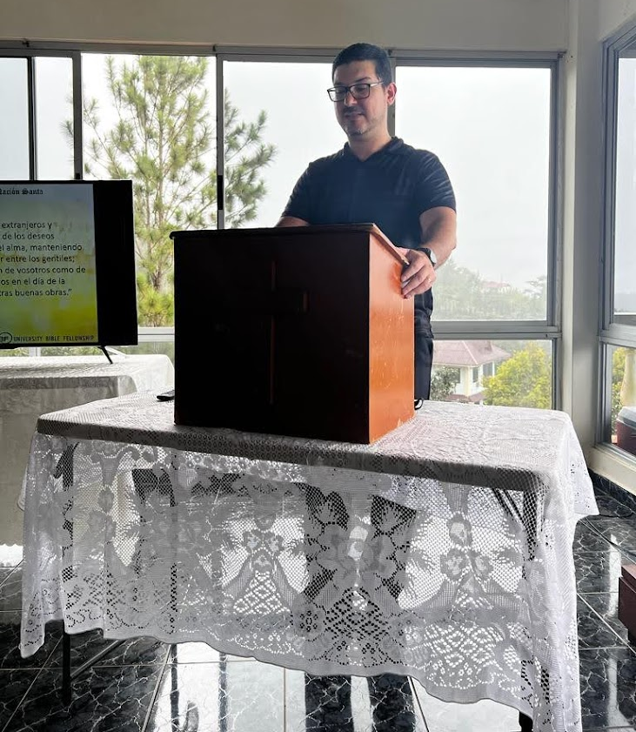
Afterwards, M. Josué delivered the Lecture 2: “You Are Royal Priesthood and Holy Nation” based on 1Pe. 2:9-12. He invited us to live as chosen people, royal priesthood, holy nation and God’s special possession by obeying the Word of God, praying for the students and going to the campus to share the gospel with them. Many attendants were moved to the tears and expressed their desire to live their identity in God and share the Gospel with others.
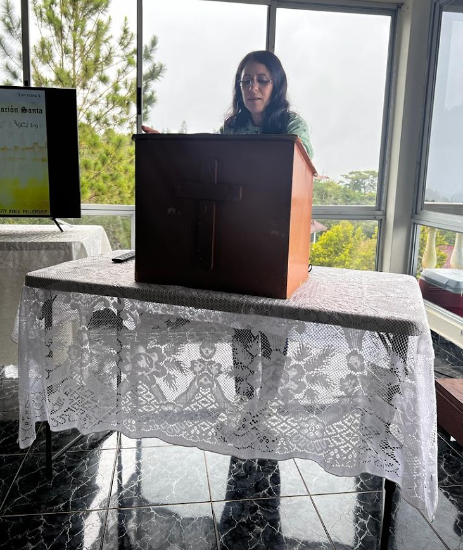
Right after the message, short term missionary Sharon Vera shared her mission report. After six years in Panama she is returning to Venezuela in Dec. 12th. She came to Panama to support M. Josué and Maria at home by babysitting their daughters and to support in the ministry as well. After almost 3 years supporting them, she found a job and kept supporting the ministry. She supported the discipleship trainings, she helped at the conferences by preaching messages, sharing testimonies and preparing seminaries. She was a valued coworker while she was in Panama. We pray that her may find her purpose and mission in Venezuela and continue to serve to the Lord with her gifts.
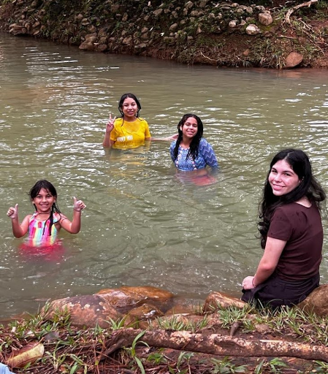
We finished our Conference with a barbecue and then went to the river to have some fellowship. All of us had a wonderful time during the conference and most of the first-time attendants were asking when are we having another one.

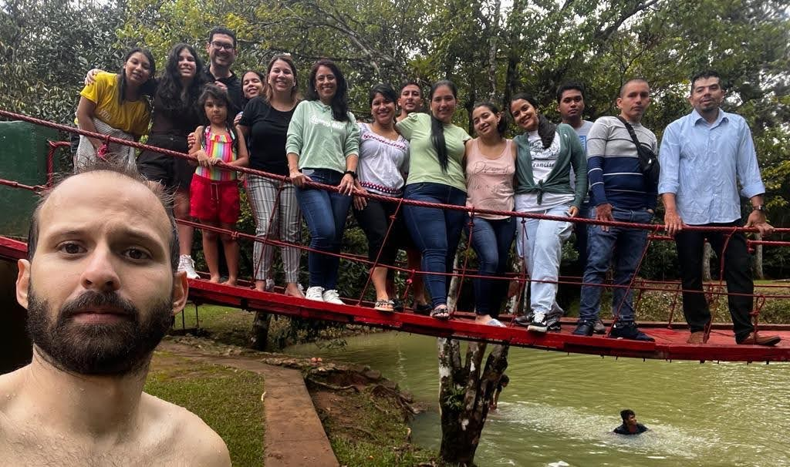
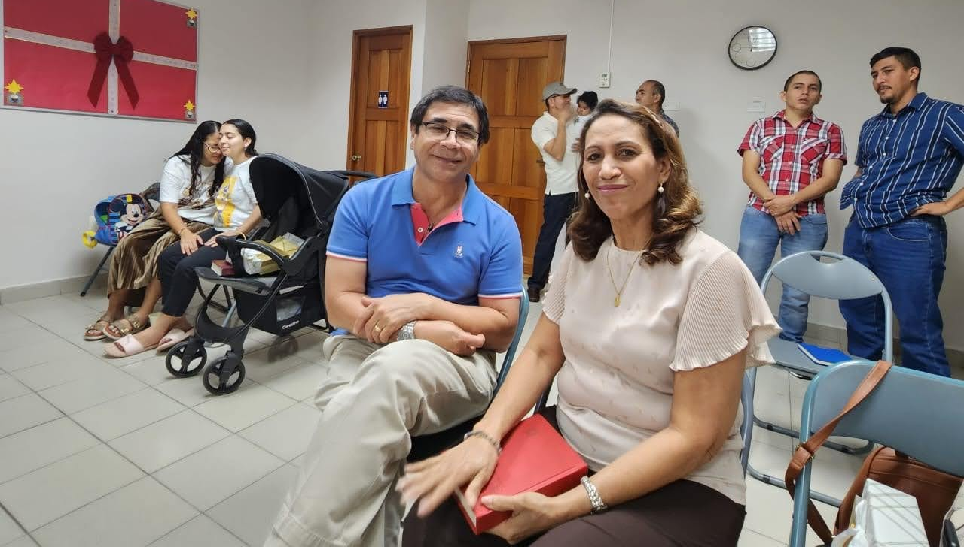
Mother’s Day in Panama is celebrated on Dec. 8th, so on Sunday, Dec. 4th (next Sunday after the conference), we had a Special Worship Service to celebrate our mothers. Many of our members are foreigners, so our moms are not in Panama. But D. Dario’s mother and father attended our SWS. Also we had the visit of M. Juan and Susana Baek (former missionaries in Panama, now in Venezuela). M. Josué delivered a Special Lecture on Luk. 1:5-25, 57-66 entitled: “And You Are to Call Him John” where we learned about Elizabeth’s righteousness, obedience and patience to wait in the Lord. M. Josué invited to all of the mothers and to all attendants in general to live observing all the Lord’s commands as Elizabeth did and to look always for the will of God which is better than our own thoughts and opinions.

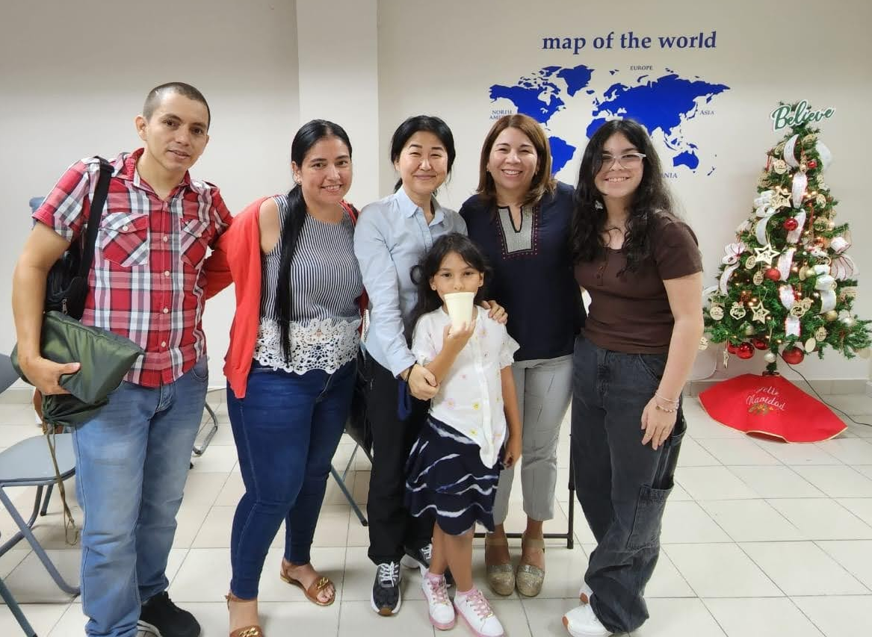
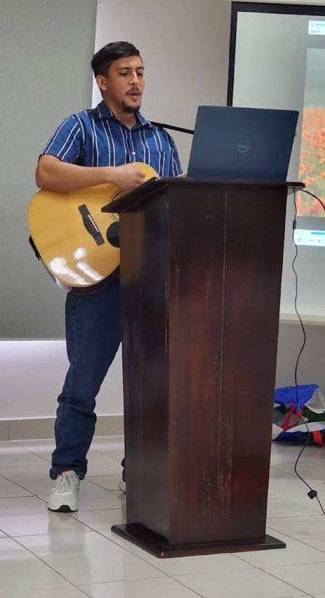
After the message D. Dario played a special song for the moms which drove them to tears. And we gave presents to all seven mothers who attended, two of them were Fergie and Natalia who also attended the conference and were encouraged to start to study the Bible and to worship with us. We pray for them to keep attending and to stablish 1:1 Bible Study. We also pray for Christian, Carlos and Melquiades with same topic.
On Dec. 11th we will have our Christmas Worship Service entitled: “And You Are to Call Him Jesus” based on Luk. 1:26-38. Please pray for M. Josué to preach the message with the power of the Holy Spirit and he may present Jesus as the reason of Christmas and the gift of God for the humankind. We pray all of the invitees may attend the Christmas SWS and many could meet Jesus. Amen.

Prayer Topics:
- Panama becomes into a Kingdom of Priests and a Holy Nation.
- To raise Abraham and Sarah of faith.
- M. Josué be filled by the Holy Spirit to prepare and deliver the Sunday Messages in Matthew.
- Dario and Karen may be good coworkers.
- To go to the campus again to reach the students in next semester
Reported by M. Josué Gutierrez (maikerg@gmail.com)

